**1St Assignment**

**Spring Boot Project Setup and Version Control Workflow**

1. **Create a New Project with Spring Initializr**

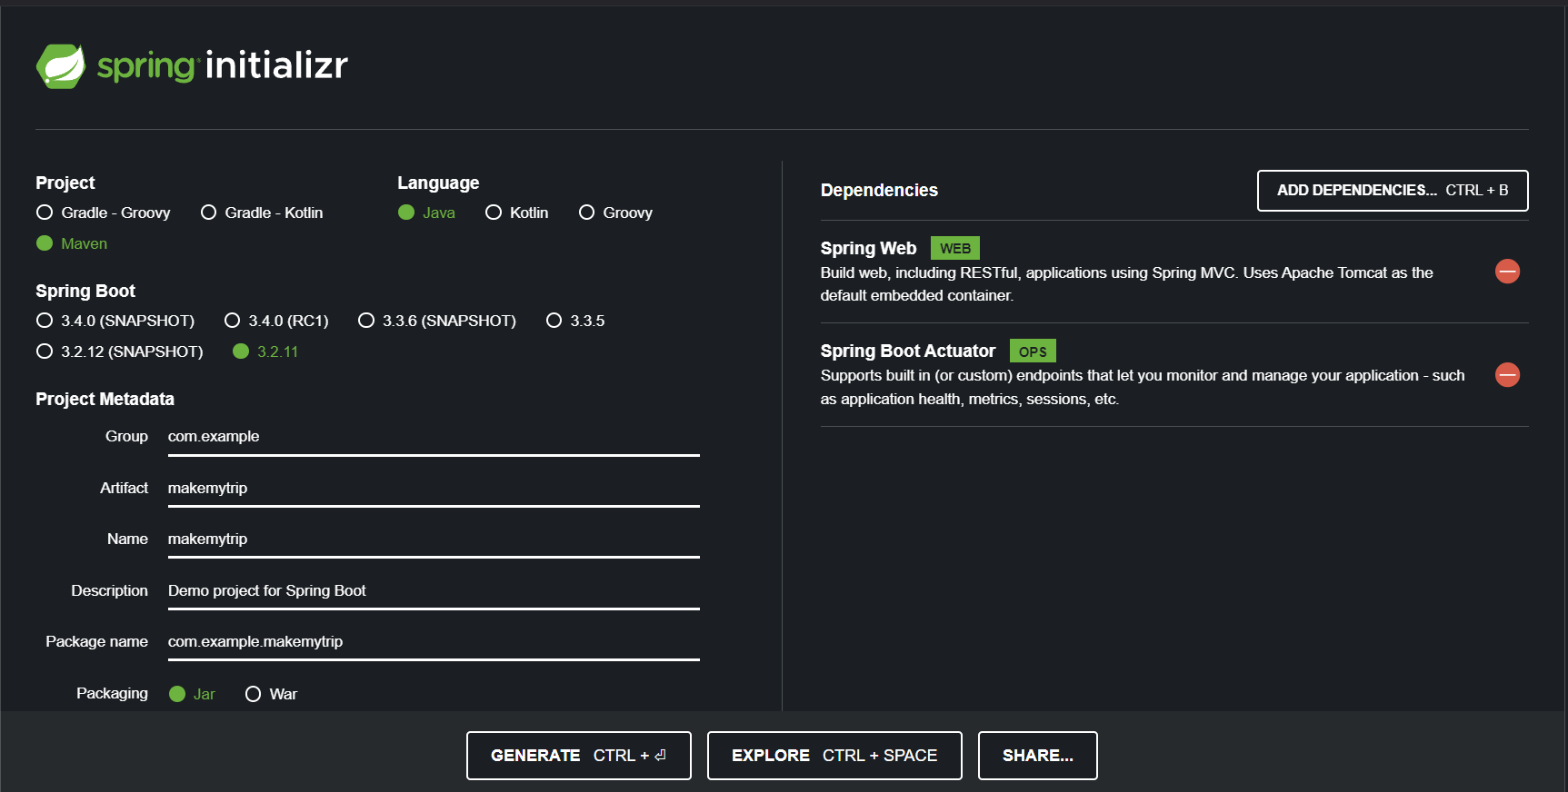

* + Go to [Spring Initializr](https://start.spring.io/).
  + Set up your project with desired dependencies (e.g., Spring Web).
  + Click **Generate** to download the project ZIP file.

1. **Set Up Workspace**
   * Create a folder named myworkspace in the C drive.
   * Extract the downloaded project ZIP file into C:\myworkspace.
2. **Create a GitHub Repository**
   * Go to [GitHub](https://github.com/) and create a new repository.
   * Copy the repository URL for use later.
3. **Build and Run the Spring Boot Application**
   * Open a terminal, navigate to your project folder in myworkspace, and run these commands:

bash

Copy code

mvn clean compile # Compiles the project

mvn clean package # Packages the project as a JAR file

mvn spring-boot:run # Runs the Spring Boot application

* + Verify the application is running at http://localhost:8080.

1. **Connect to GitHub**
   * Open your IDE (IntelliJ IDEA or VS Code).
   * Go to **VCS** (Version Control System) and select Git.
   * Connect to the GitHub repository by pasting the repository URL.
   * Push the code to GitHub:

bash

Copy code

git push origin master

1. **Create Branches**
   * Create the following branches in your local repository:

bash

Copy code

git branch master # Creates master branch (if not already created)

git branch prod # Creates prod branch

git branch preprod # Creates preprod branch

git branch dev # Creates dev branch

1. **Fetch and Work on the dev Branch**
   * Fetch branches from the remote repository:

bash

Copy code

git fetch origin

* + Switch to the dev branch:

bash

Copy code

git checkout dev

* + Stage, commit, and push changes to the dev branch:

bash

Copy code

git add .

git commit -m "Initial commit on dev branch"

git push origin dev

1. **Merge dev into preprod on GitHub**
   * Go to your GitHub repository.
   * Open a Pull Request (PR) to merge the dev branch into the preprod branch.
   * Review and merge the PR to complete the process